**MACHINE LEARNING MODEL DEPLOYMENT WITH IBM CLOUD WATSON STUDIO**

**MACHINE LEARNING BLOCK DIAGRAM:**

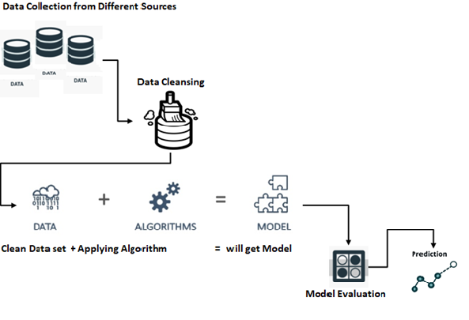

**DATASET AND ITS PROPERTY:**

The dataset had been taken from the kaggle to process the machine learning model to predict the correct and accurate value of the prediction.

Dataset link: [click here for dataset](https://www.kaggle.com/datasets/shivan118/big-mart-sales-prediction-datasets).

**PREPROCESSING:**

Before a model can be deployed, it needs to be trained. This involves selecting an algorithm, setting its parameters and training it on prepared, cleaned input data. All of this work is done in a training environment, which is usually a platform designed specifically for research, with tools and resources required for experimentation. When a model is deployed, it is moved to a production environment where resources are streamlined and controlled for safe and efficient performance.

**Validate the ML Model**

Once a model has been trained and its results have been deemed successful, it needs to be validated to ensure that its one-time success was not an anomaly. Validation includes testing the model on a fresh data set and comparing the results to its initial training. Of those that are validated, usually only the most successful model is deployed.

Validation also includes reviewing the training documentation to ensure that the methodology was satisfactory for the organization and that the data used corresponds to the requirements of end users.

**Deploy the ML Model**

The process of actually deploying the model requires several different steps or actions, some of which will be done concurrently.

Third, the people who will be using the model need to be trained in how to activate it, access its data and interpret its output.

**Monitor the ML Model**

The monitor stage of the data science lifecycle begins after the successful deployment of a model.Model monitoring ensures that the model is working properly and that its predictions are effective. Of course, it’s not just the model that needs to be monitored, particularly during the early runs. The deployment team needs to ensure that the supporting software and resources are performing as required, and that the end users have been sufficiently trained. Any number of problems can arise after deployment: Resources may not be adequate, the data feed may not be properly connected or users may not be using their applications correctly.

The best way to monitor a model is to routinely evaluate its performance in its deployed environment. This should be an automated process, using tools that will track metrics to automatically alert you should there be changes in its accuracy, precision or F score.

**FEATURES OF MACHINE LEARNING:**

* **Predictive modeling:** Data is used by machine learning algorithms to create models that forecast future events. These models can be used to determine the risk of a loan default or the likelihood that a consumer would make a purchase, among other things.
* **Automation:** Machine learning algorithms automate the process of finding patterns in data, requiring less human involvement and enabling more precise and effective analysis.
* **Scalability:** Machine learning techniques are well suited for processing big data because they are made to handle massive amounts of data. As a result, businesses can make decisions based on information gleaned from such data.
* **Generalization**: Algorithms for machine learning are capable of discovering broad patterns in data that can be used to analyze fresh, unexplored data. Even though the data used to train the model may not be immediately applicable to the task at hand, they are useful for forecasting future events.
* **Adaptiveness**: As new data becomes available, machine learning algorithms are built to learn and adapt continuously. As a result, they can enhance their performance over time, becoming more precise and efficient as more data is made available to them.